How to setup Acquia cloud Dev environment?

Create User Account in Acquia cloud

Create an application with latest Drupal version



Application created

Install Drupal

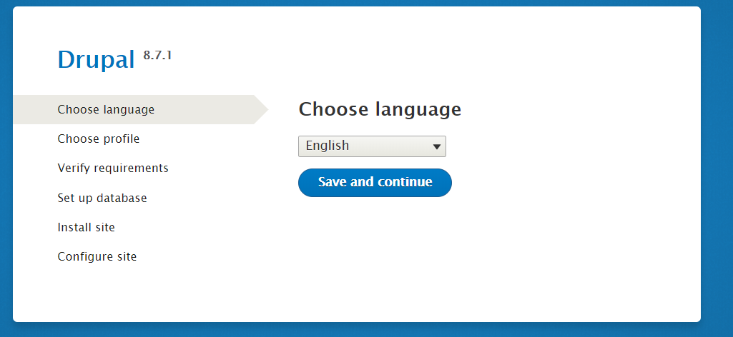

Drupal Installed.

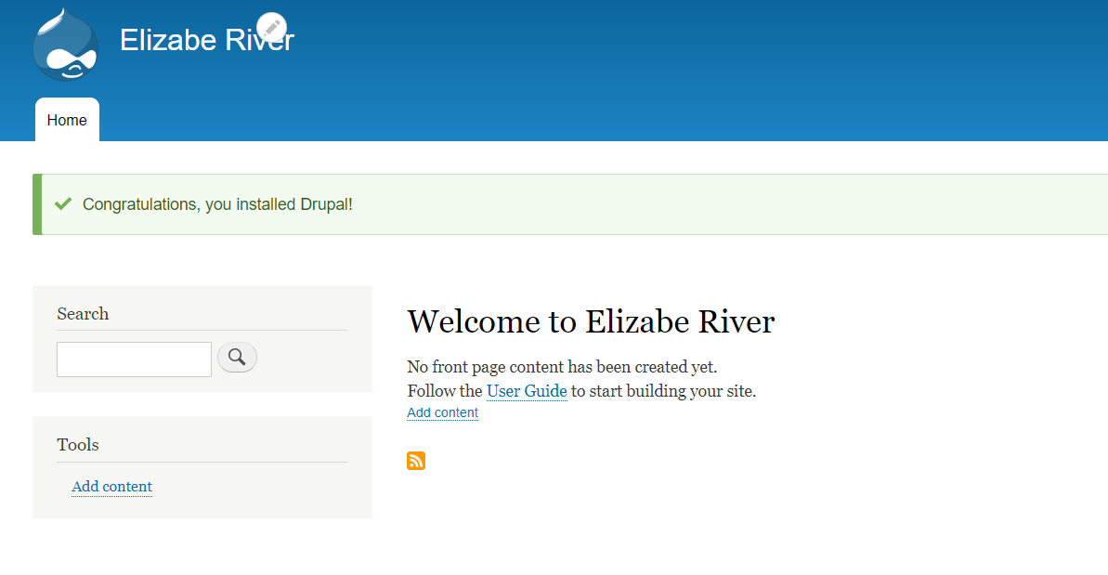

Acquia Dev environment is ready to work.

How to create SSH Key?

SSH Key:

<https://docs.acquia.com/acquia-cloud/manage/ssh/generate/#requirements>

Open Gitbash

Navigate to C:\Users\560235\.ssh

Run ssh-keygen

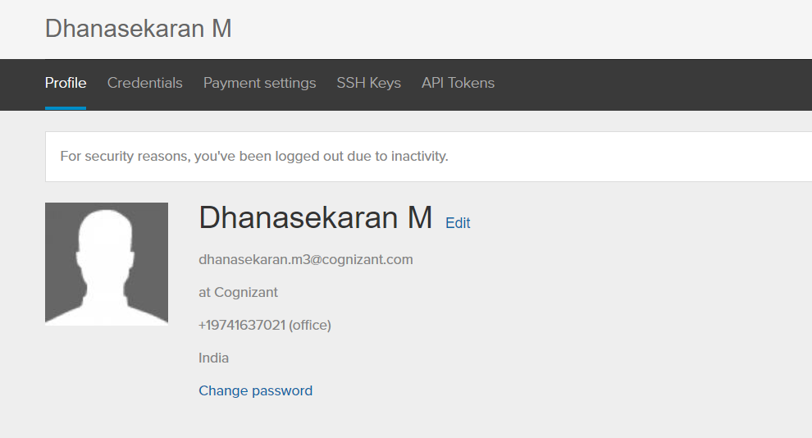

If something is not working, then delete known_hosts file C:\Users\560235\.ssh

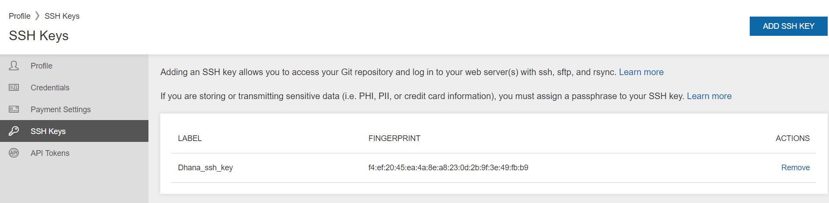

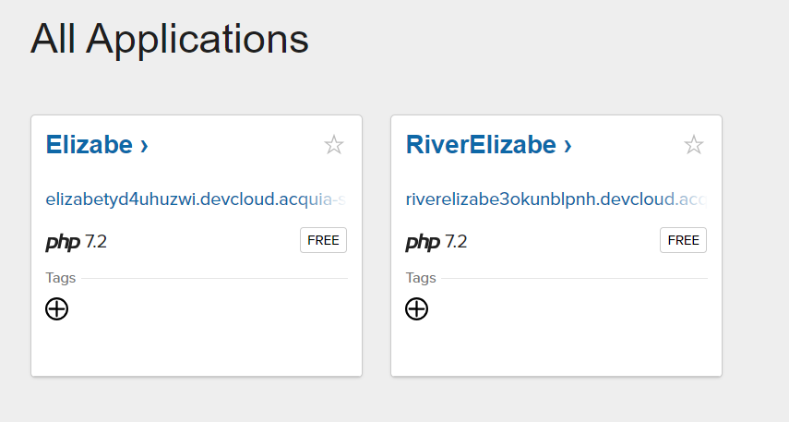

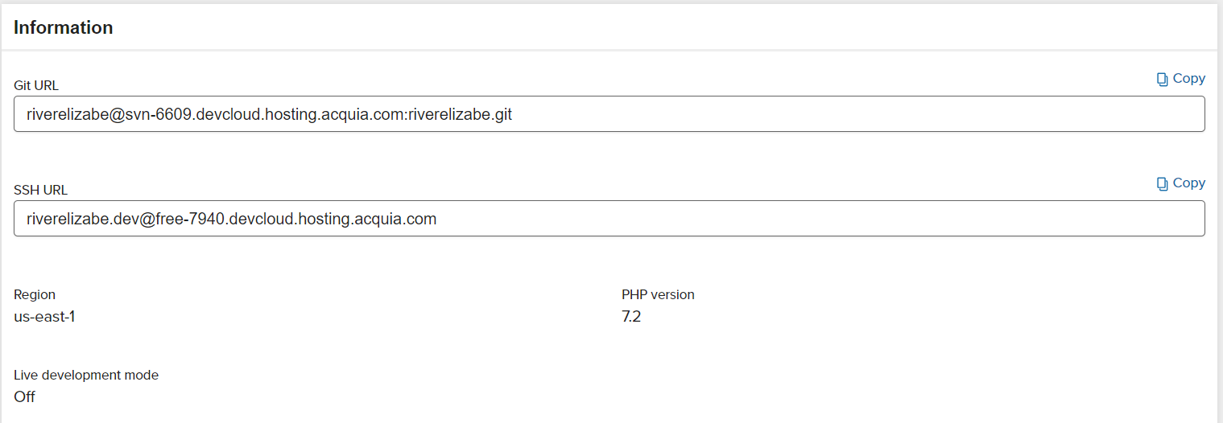

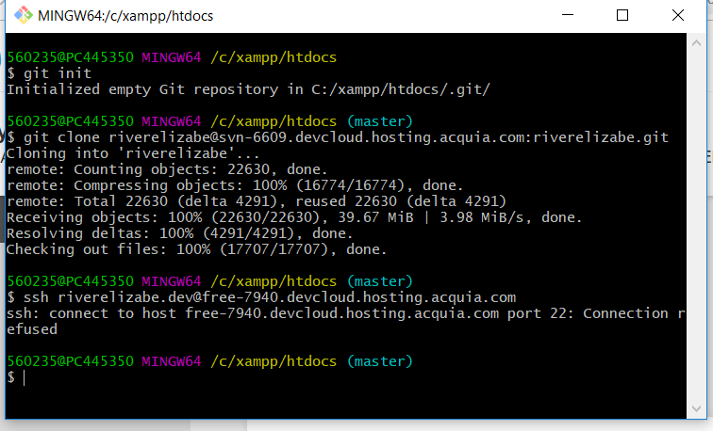

Due to firewall Issue, ssh command could not connect to the server.

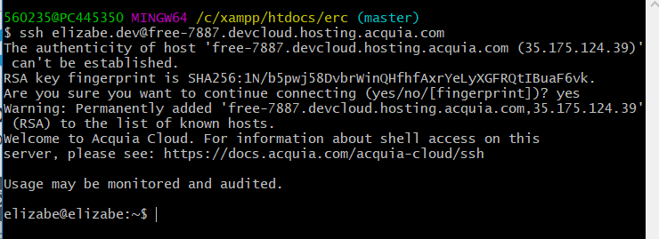

**Deploy Database to other Application in Acquia cloud**

1. Copy database file from localhost to new Application/Site:

Open Git bash and navigate to localhost

Command: scp -r elizabe.sql.gz [riverelizabe.dev@free-7940.devcloud.hosting.acquia.com:/mnt/gfs/riverelizabe.dev/backups/](mailto:riverelizabe.dev@free-7940.devcloud.hosting.acquia.com:/mnt/gfs/riverelizabe.dev/backups/)

Database file .sql is copied to mnt/gfs/riverelizabe.dev/backups/ folder.

1. Import database to new Application/Site:

Connect to ssh using below command

Command: ssh [riverelizabe.dev@free-7940.devcloud.hosting.acquia.com](mailto:riverelizabe.dev@free-7940.devcloud.hosting.acquia.com)

Drop the old DB and import the new DB using the below command.

drush @riverelizabe.dev ah-db-import /mnt/gfs/riverelizabe.dev/backups/elizabe.sql.gz –drop

How to setup localhost in your machine?

Add SSH Key

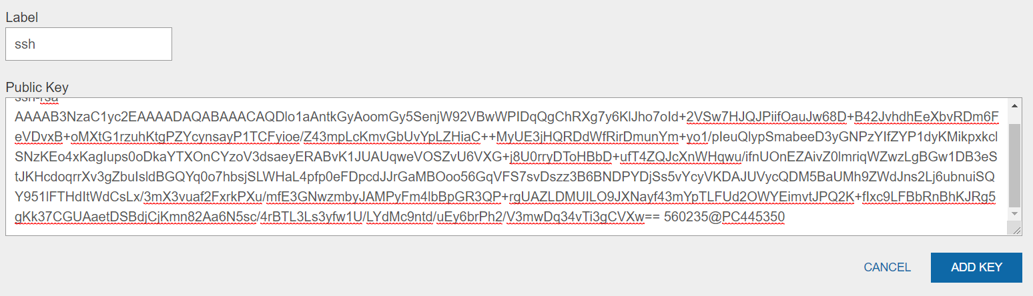

SSH Key added.

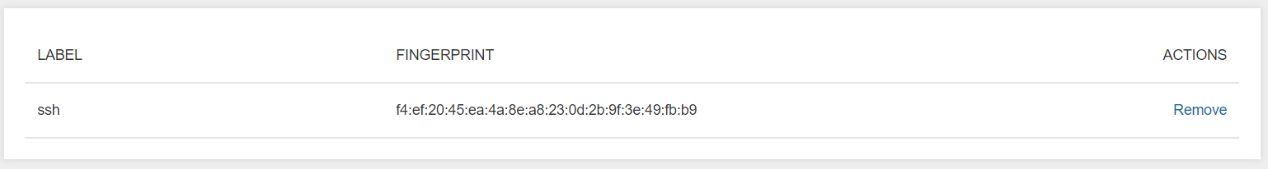

Go to xampp/htdocs

Open Git bash

Git init

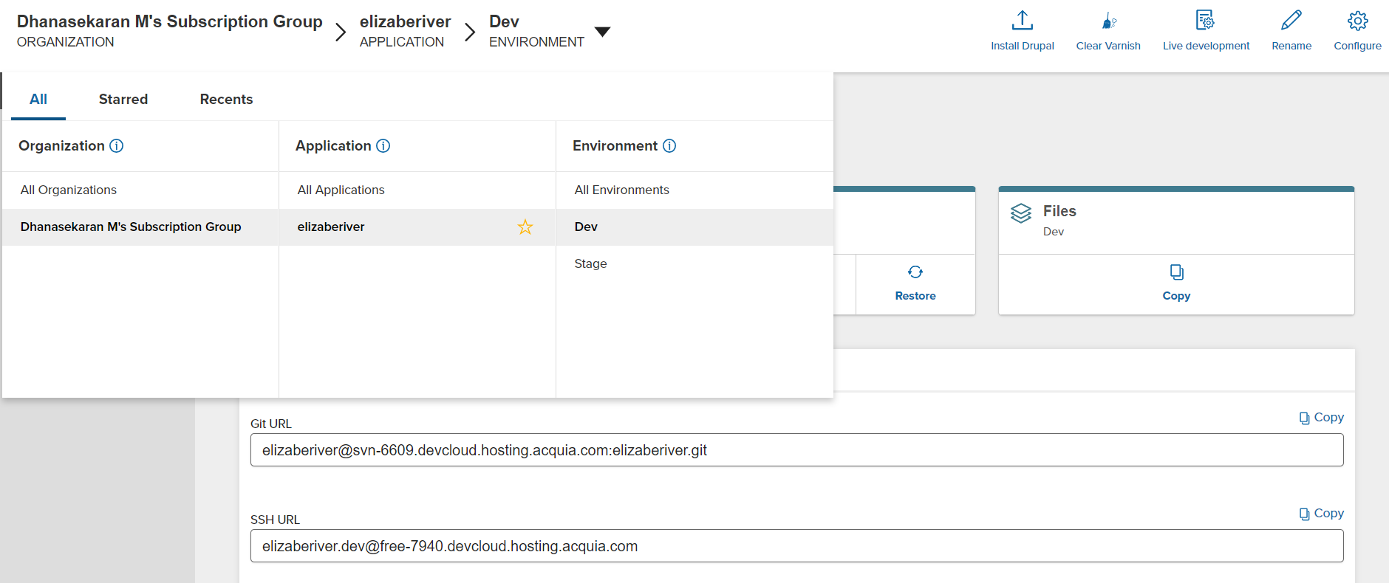

Git clone elizaberiver@svn-6609.devcloud.hosting.acquia.com:elizaberiver.git

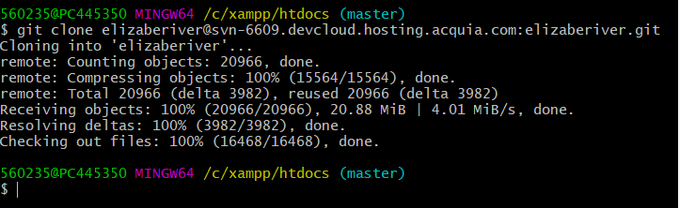

Source code pulled in to local host.

Backup database

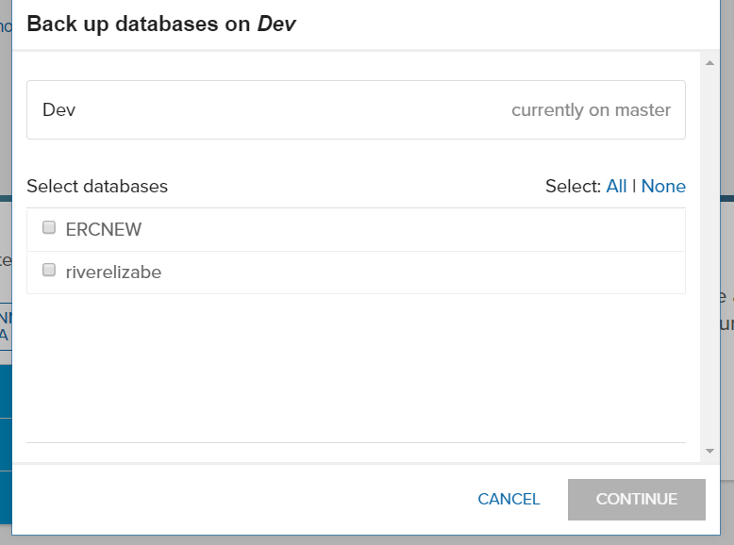

Database back up done.

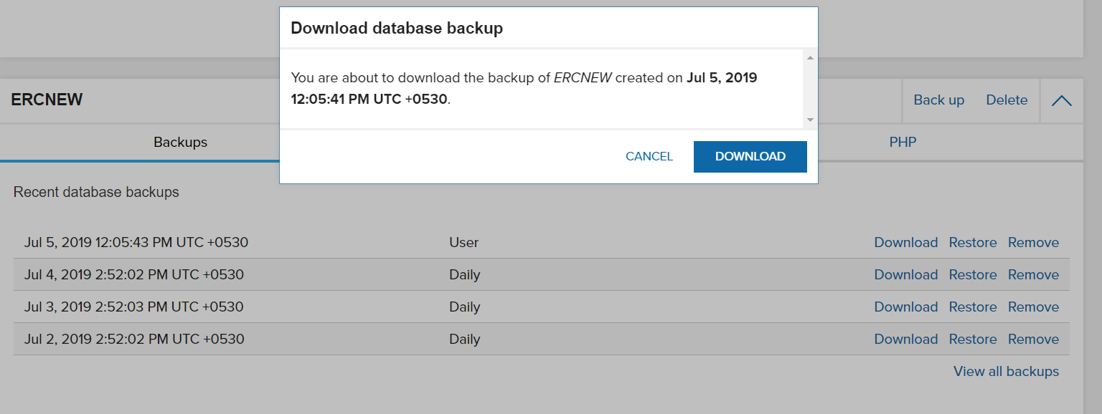

Download the DB for local setup

In local host, Import DB.

Configure database and hash salt in settings.php

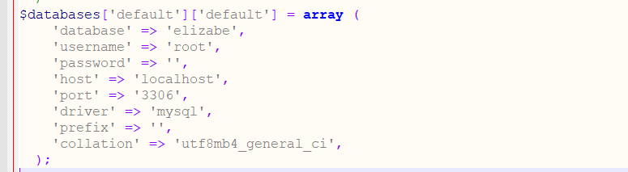



Localhost started to run the application.

How to migrate Database to new application?

|  |  |
| --- | --- |
|  |  |
|  |  |
|  | 1. Copy database file from localhost to new Application/Site: |
|  | Open Git bash and navigate to localhost |
|  | Command: scp -r elizabe.sql.gz riverelizabe.dev@free-7940.devcloud.hosting.acquia.com:/mnt/gfs/riverelizabe.dev/backups/ |
|  | Database file .sql is copied to mnt/gfs/riverelizabe.dev/backups/ folder. |
|  |  |
|  | 2. Import database to new Application/Site: |
|  | Connect to ssh using below command |
|  | Command: ssh riverelizabe.dev@free-7940.devcloud.hosting.acquia.com |
|  | Drop the old DB and import the new DB using the below command. |
|  | drush @riverelizabe.dev ah-db-import /mnt/gfs/riverelizabe.dev/backups/elizabe.sql.gz –drop |